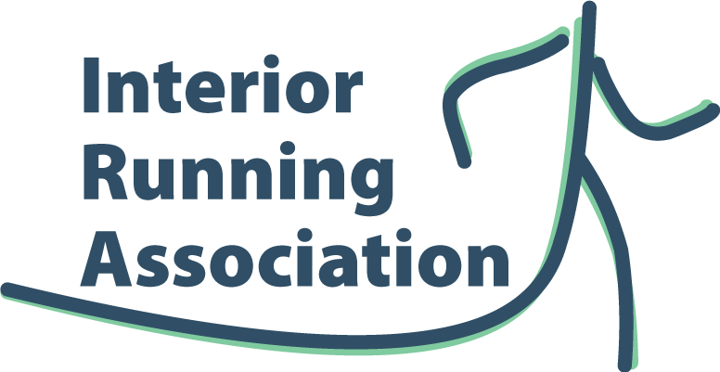
Interior Running Association
Guidelines for Promotion of Events

Introduction

This document sets out guidelines for promotion of running events that are either: 1) part of the Interior Running Association (IRA) Road Race (RR) Series and Cross-Country (XC) Race Series, or 2) not part of the IRA RR / XC race series.
Promotion of running events is aligned with at least three of the purposes of the IRA as set out in the IRA Constitution and these are:
- To promote road running and cross country running in the Okanagan Valley, Kamloops, Salmon Arm, Revelstoke and other communities in British Columbia;
- To assist and support other existing associations, organization and programs that are not at variance with the objectives and aims of the Society;
- To promote and arrange racing competitions and to offer, grant and contribute towards prizes and awards and distinctions;
Promotion of running events is important for making the running community aware of upcoming events and encouraging participation in these events. Historically, the IRA has focused on promoting running events that are part of the IRA Road and XC race series through posts on the IRA website and social media (e.g. Facebook, Instagram, twitter). Also, the IRA can assist, as needed, the race directors of IRA series events with the planning, registration, results, awards and draw prizes for these events.
However, from time to time, the IRA receives requests to promote running events that are not part of the IRA Road or XC series. To ensure that these requests are managed fairly, consistently and aligned with the purposes of the IRA, the following guidelines have been developed for use by the IRA executive and members.

Guidelines
Apply the following guidelines for determining which events the IRA will promote and how this will be done:
- FOR IRA SERIES EVENTS:
- For running events that have been approved to be included in the IRA road race or XC race series, the events will continue to be promoted by the IRA through the existing methods by the IRA executive, i.e. on the IRA website, social media (e.g. Facebook, Instagram), inclusion on the BC Athletics calendar and other.
- FOR OTHER EVENTS:
- For running events that are not currently part of the IRA Road or XC Series, the request for IRA promotion of the event can be received by any member of the IRA Executive who will bring it to the attention of the IRA President, e.g. via email.
- The IRA President will review the request and consult with other members of the IRA Executive if needed, to ensure the event aligns with the purposes of the IRA and would be eligible for sanctioning by BC Athletics. If so, the President would post information about the event (including link to the event website) on the IRA website. If the event does not meet the minimum criteria for posting on IRA website, the President would respond to the event organizer and explain reasons why the IRA could not promote their event.
- The IRA President would also reach out to the event organizers to explain the purposes of the IRA, the support the IRA could provide and invite them to apply to be part of the IRA RR or XC series.

